Foundation of Nursing Studies

Inspire ◦ Enable ◦ Improve

Resilience-based Clinical Supervision Project Manager and Facilitator
The Foundation of Nursing Studies (FoNS) is seeking a likeminded and enthusiastic Project Manager and Facilitator to manage our Resilience-based Clinical Supervision (RBCS) programme.

Main Job Purpose: As a Project Manager / RBCS Facilitator you will work within the FoNS team to lead the day to day management of the RBCS programme
Responsible and professionally accountable to: Chief Executive
Reports to: RBCS Programme Lead
Hours of Work: 0.6 - 0.8 FTE – negotiable at either
Terms of Employment: permanent / secondment opportunities. 3-month probation period. Predominantly home working with travel as required, including to London based office
Salary: £45,879 - £50,056 (or band 7 equivalent if secondment)
Holiday: Up to 25 days per year (pro-rata if part time) + Public Holidays (pro-rata if part time)
Pension: A maximum of 8% employer’s contribution

For further information and/or to arrange an informal discussion
regarding the post please contact:

Grace Cook
rbcs@fons.org

Closing Date: 27th August 2024 5pm
Virtual interviews: 4th September 2024
Second stage interview (facilitation): 17th September 2024

Foundation of Nursing Studies

Inspire ◦ Enable ◦ Improve

FoNS Project Manager/Facilitator– Job Description and Person Specification

The Foundation of Nursing Studies is a charitable organisation established to advance education amongst the members of the nursing profession and to embed research into practice. FoNS believes all individuals should experience health and social care as person-centred, safe and effective. This includes those who are receiving care and those who are giving care.

FoNS works towards this vision by working with nurses and nurse-led teams to co-create and deliver a variety of learning opportunities that help to develop their knowledge, skills and confidence in leading and facilitating change that improves care experiences and outcomes. For further information please see our website: https://www.fons.org/aboutus/

FoNS has been facilitating RBCS since 2020 and due to the success, growth and establishment of the programme are seeking an NMC registered project manager and facilitator to support the day-to-day running of the programme. You can find out more information about RBCS and the programme we run here: https://www.fons.org/programmes-development-opportunities/clinical-supervision/. The FoNS RBCS Team is set out as follows:
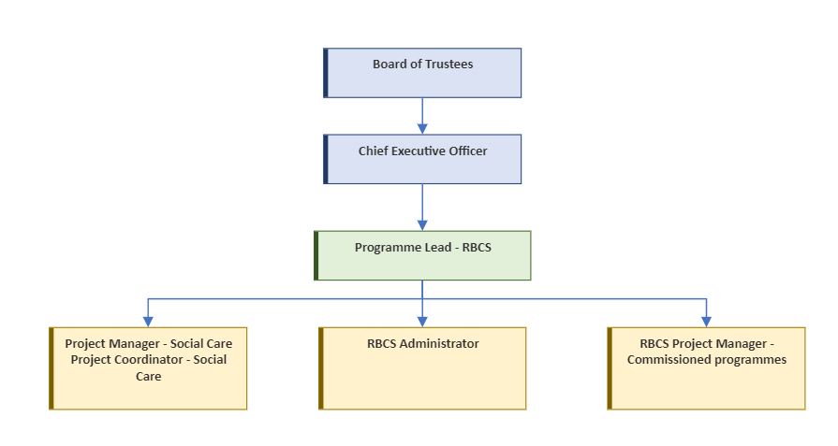

Key Responsibilities

Working as a core member of the FoNS RBCS Team to deliver the programme:

- Facilitating RBCS programmes
- Implementing and managing the communications and marketing plan
- Managing stakeholder relationships and engagement
- Identifying and managing risks alongside the programme lead
- Working with the RBCS administrator to manage the day-to-day end-to-end running of the programmes
- Leading and supporting FoNS Associate facilitators to deliver FoNS RBCS programmes and facilitate and organise regular supervision sessions
- Managing resources
- Conducting evaluations of RBCS with the programme lead
- Managing end-to-end finances for each programme with the support of the FoNS Finance Manager
- Supporting any call for applications and subsequent selection processes for associate facilitators and staff as required
- Representing FoNS on national and international fora in relation to reflective practice such as national steering and advisory groups on health and wellbeing/clinical supervision
- Writing for publication (report writing, regular blogs, social media, peer reviewed journals, nursing press)

Other:

- Undertaking any other activities that may be considered appropriate towards supporting and achieving the aims of the organisation and your own professional development. There will be opportunities for development into facilitating other programmes within FoNS
- Taking responsibility for maintaining registration through revalidation with the NMC and working within the parameters of The NMC Code and scope of professional practice

RBCS Project Manager and Facilitator – Person Specification

As an organisation we are on a journey towards equality, diversity and inclusion. We welcome applications from across all communities and backgrounds, including those from ethnic minority groups, those with disabilities and those from the LGBTQ+ community.

ATTRIBUTES | ESSENTIAL | Desirable
Education and Qualification | - Current NMC registered Nurse/Midwife  - Relevant first degree or equivalent experience commensurate with level of study  - Evidence of ongoing continuing professional development | - Masters level or above qualification or equivalent experience commensurate with level of study  - Post graduate study in education and practice (i.e. PGCE)
Knowledge and Experience | - Significant post registration experience across a range of settings  - Experience of facilitating  - Project managing programmes  - Quality and service improvement  - Experience of using a range of evaluation methods | - Experience of facilitating RBCS or a similar programme of clinical supervision  - Project Management qualification or experience  - Understanding of person-centred workplace cultures  - Experience of practice-based evaluation and research using a range of methods
Skills and Abilities | - Good facilitation ability  - Leadership  - Critical thinker  - Able to inspire innovation  - Promote and share good practice  - Able to develop, implement and evaluate innovation in practice  - Able to organise and prioritise workload with minimal day-to-day supervision  - Excellent communication and presentation skills  - Effective standard of writing and ability to prepare and edit information with accuracy  - Good organisational and administrative skills including coordination of people and resources  - IT literate - proficient in virtual platforms such as MS Teams, Zoom, Office 365  - Willingness to engage in social media for professional purposes | - Able to manage resources and budgets and maintain financial balance
Personal Attributes/  Circumstances | - Committed to person-centred practice and ways of working  - Appreciation of patient/carer expertise and involvement  - Enthusiastic and self-motivated  - Kind and compassionate  - Able to develop good team working relationship with others  - Able and willing to travel as required  - Comfortable working within the virtual environment  - Willing to work flexibly sometimes outside normal working hours or be away from home overnight

FoNS RBCS Project Manager and Facilitator - Application Form

It is essential that all sections are completed in full and submitted by email along with your up-to-date curriculum vitae and covering letter/supporting statement demonstrating your suitability for the post.
If saved as a word document the boxes will expand as text is added.

1. Title:
2. First Name:
3. Last Name:
4. NMC PIN:
5. Contact details:
Address:
Postcode:
Telephone/mobile:
Email:

Please indicate preferred method of contact:
6. References - Please provide details of two referees (one must be your current employer)

Full Name of Referee 1:
Job Title:
Address:
Postcode:
Telephone:
Email:

Full Name of Referee 2:
Job Title:
Address:
Postcode:
Telephone:
Email:

7. Rehabilitation of Offenders Act

Have you any criminal convictions? Please answer Yes or No:
Is there any relevant court action pending against you? Please answer Yes or No:
If ‘Yes’ to either question, please provide further details.

NB There is no requirement to disclose convictions that are spent under the Rehabilitation of Offenders Act 1974 unless you are advised that the post for which you are applying is exempt and a Criminal Records Bureau Disclosure will be required.
8. Confirmation of Detail and Declaration:

I declare that the information given in this application (including CV and cover letter/supporting statement) is, to the best of my knowledge, complete and correct and that it will be used to process my application. I understand that if, after appointment, any information is found to be inaccurate this may lead to disciplinary action or dismissal without notice.

I declare that all the above information is correct.

Signature:

Date:

NB Electronic signatures will be accepted along with scanned copies of a hand-signed document
9. Data Protection and Privacy
Your privacy is important to us. FoNS works in line with UK law on data protection and you can read more about FoNS’ data privacy policy via https://www.fons.org/privacy-policy. By submitting this application form, you are consenting to FoNS holding the data this form contains for the purposes of processing this application. FoNS will not share this information with third parties. However, FoNS staff will review applications as part of the selection process and may use external consultants as part of the application process. Information about the successful applicant will be posted on the FoNS website and in social media along with photographs taken as appropriate.

Please send the completed and signed form, a CV and covering letter with a supporting statement about why you feel you would be suitable for this role to:
Grace.cook@fons.org

Closing Date: 27th August 2024 5pm

